ORGANIZATION LOGO 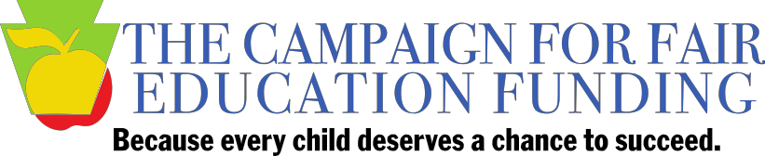

FOR IMMEDIATE RELEASE

CONTACT:
NAME, EMAIL
PHONE
Thursday [EVENT TITLE] at [LOCATION] part of statewide effort
urging action on fair funding for education

[CITY] (June 10, 2015) – Parents, educators and other community members are holding local events around the state on Thursday, June 11 to highlight the need for a new basic education funding system in Pennsylvania that ensures all students have a chance to succeed no matter where they live.
[ORGANIZATION] is sponsoring [EVENT NAME] at [TIME] Thursday at [LOCATION].
[ORGANIZATION LEADER NAME, of TITLE] said Pennsylvania has the widest funding gap between wealthy and poor school districts of any state in the country. That inequity, combined with recent cuts in state funding to public schools, has resulted in teacher layoffs and cutbacks in programs and services in many schools across Pennsylvania.
[PERSONALIZED QUOTE FROM A PARTICIPANT, e.g., “The way we fund public schools in Pennsylvania is not working, and it’s hurting our children,” said XXXXXXXXXXXX. “This is the time to fix this broken system and start investing in all of our children so they have a fair shot to succeed.”]
Just this week, the Leadership Conference Education Fund and Education Law Center (ELC) joint report "Cheating our Future: How Decades of Disinvestment by States Continues to Jeopardize Equal Education Opportunity,” detailed school funding disparities across the country and found that the state’s lack of a state funding formula combined with drastic budget cuts in recent years have caused severe inequities in Pennsylvania.
In addition, ELC's fourth annual report card, “Is School Funding Fair? A National Report Card,” gave Pennsylvania's school funding system a "D" for fairness in how state resources are allocated to districts. These reports are just the latest in a series of national research spotlighting Pennsylvania school funding inequities.
At the events, the impact of state funding on students is being amplified through a brief excerpt from the new dramatic production, School Play, a documentary-based theatre piece on Pennsylvania’s school funding issues that draws from interviews and quotes from students, parents, teachers, and others.
The Campaign for Fair Education Funding is urging state lawmakers to enact an equitable and predictable new school funding system that provides sufficient funds to all schools so every child has an equal opportunity to learn, no matter where that student lives. It also is calling on the state to address existing income and racial disparities in school funding in order to eliminate student achievement gaps.
The Campaign proposes a system to direct dollars across school districts based on the real costs to educate students, adjusting for the increased resources needed to address challenges faced by certain students, like those living in poverty and English language learners. The new system would address factors like district size and sparsity, local tax effort and district wealth, and charter school enrollment. It also would ensure that districts do not lose funds while the new formula is being phased in.
For more information about [ORGANIZATION], visit [ORGANIZATION WEBSITE]. Learn more about the Campaign for Fair Education Funding at fairfundingpa.org. Information on School Play can be found at http://www.pccy.org/initiatives/school-play/.

# # #

